**ASSIGNMENT 15.6**

**Problem Statement:**

Build and Deploy Hadoop word count program using Gradle.

Note: You can use any program of your choice.

**Solution:**

**Gradle project build:**

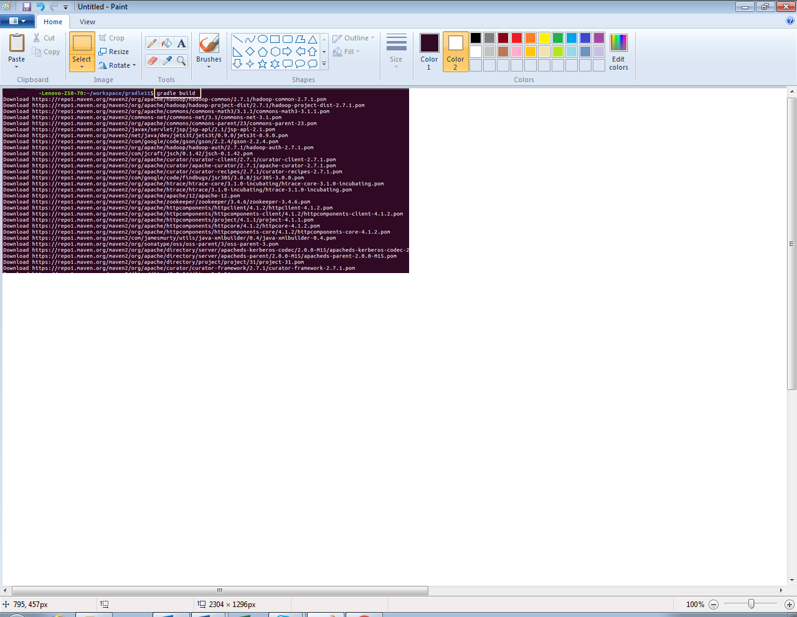

**Gradle build file:**

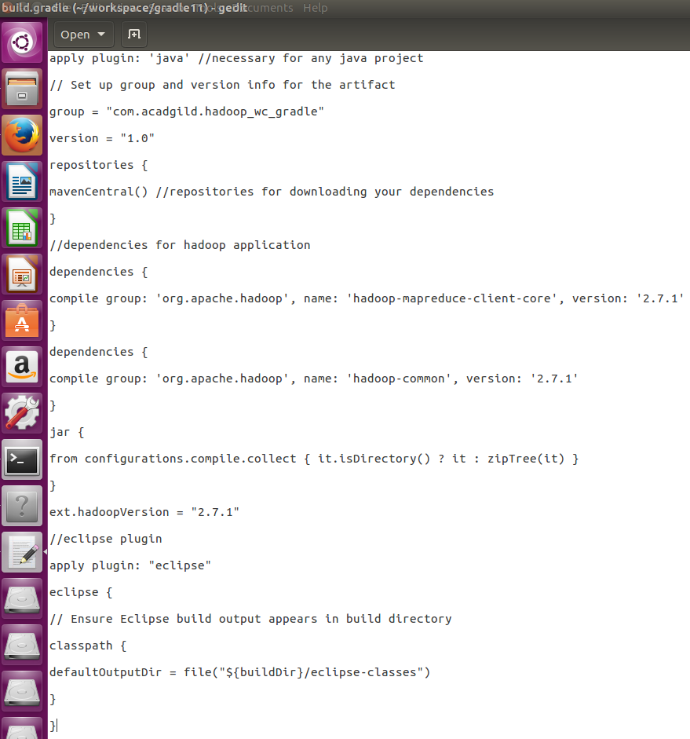

**Word count program (java code):**

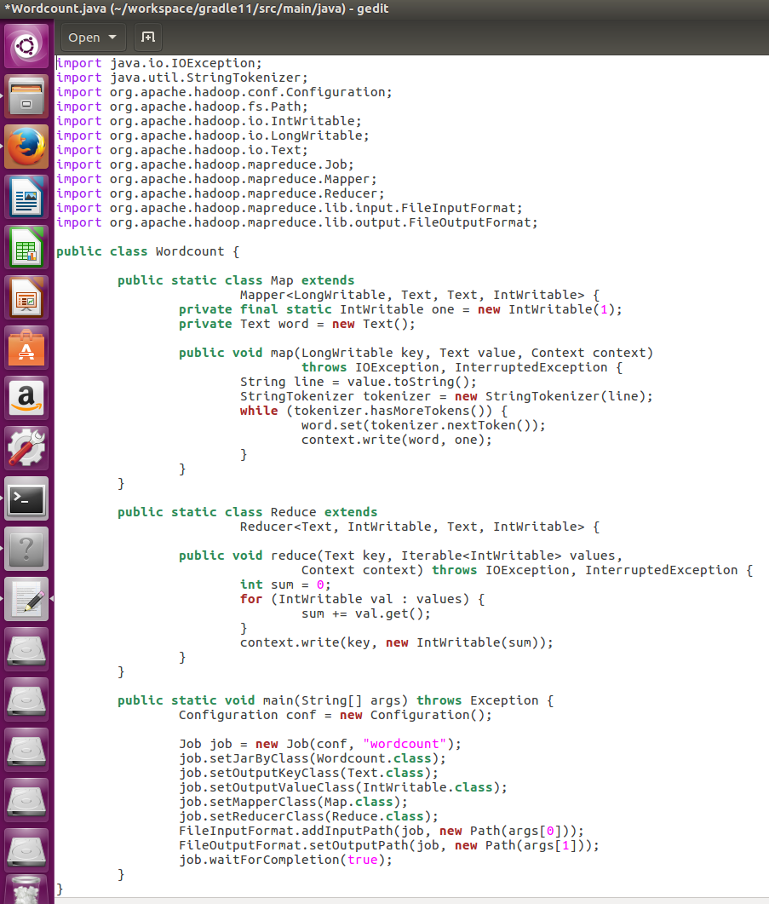

**Dataset:**

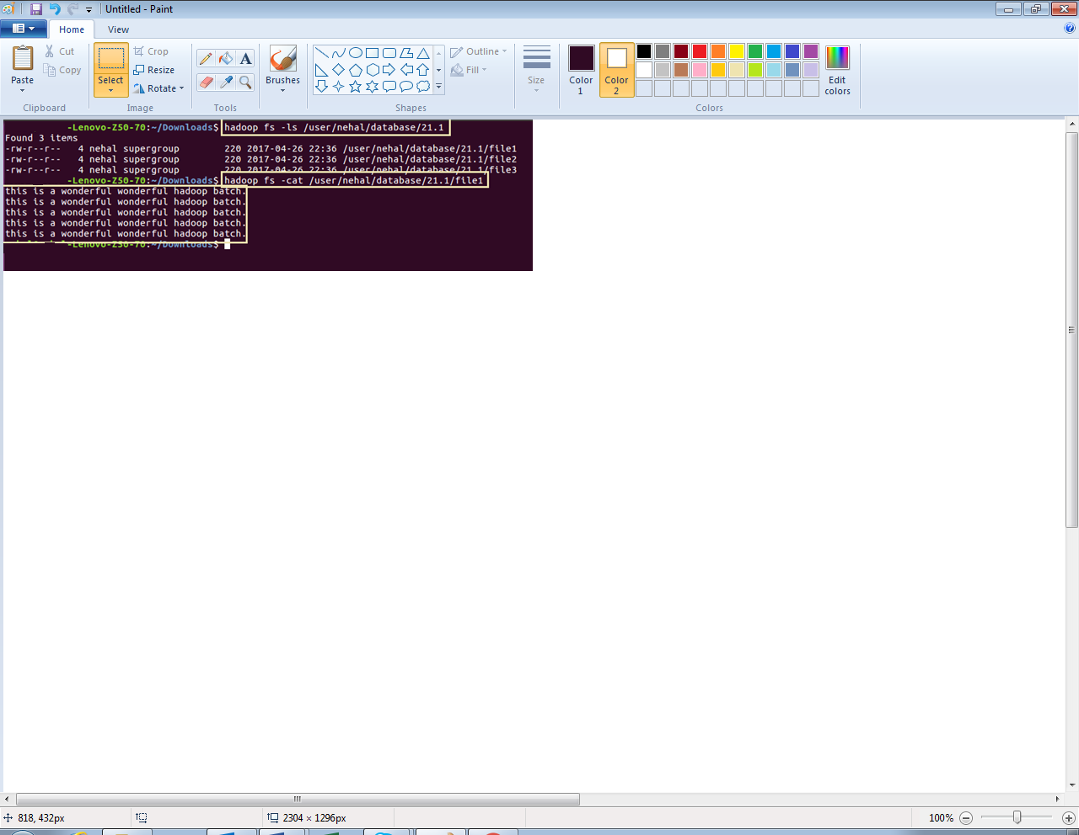

**Running gradle project (jar file):**

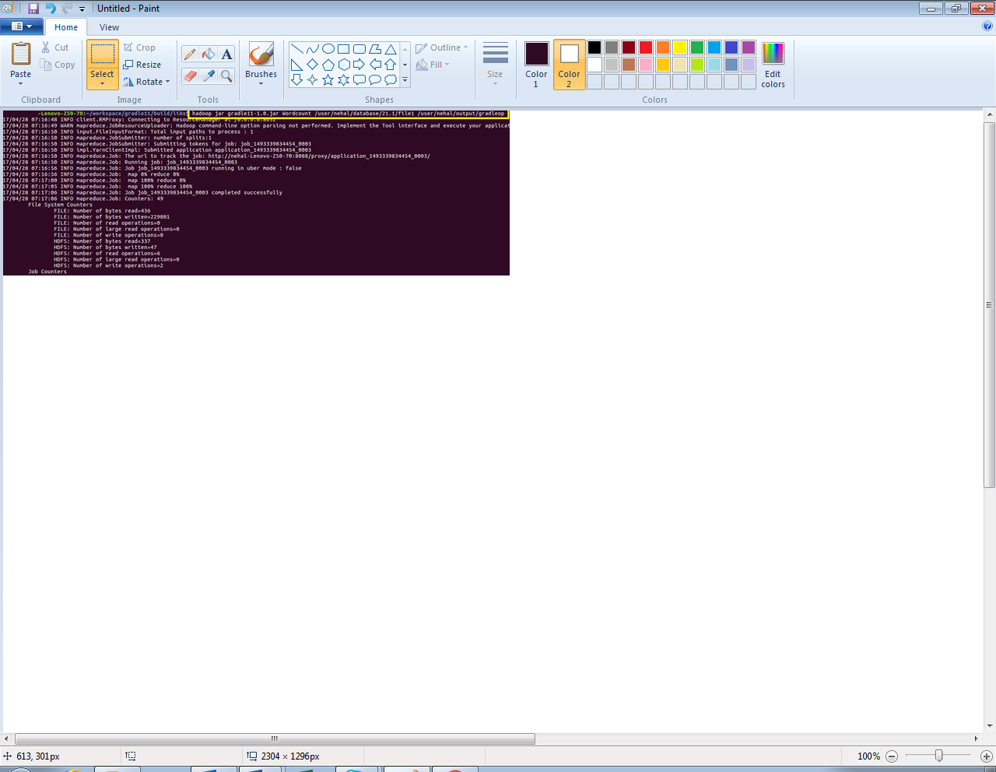

**Output:**

